Web Site Design Final Project
Team B: Codanda Appachu, Piotr Dudzicz, Joel Kemp, Daniel Ranells
Professor Chen, Professor McCracken

Contact Information
Codanda Appachu: 408-893-5310
Piotr Dudzicz: 212-810-9894
Joel Kemp: 347-257-8831
Daniel Ranells: 646-457-7734

Our project goal was to create a Web 2.0 revision of the City College of New York’s Chapter of the ACM website that incorporated features of modern web pages.
With the advent of modern Web 2.0 technologies, the aesthetics of static and even dynamic websites are becoming revolutionized, both graphically and functionally. Our team wished to capture the modern feel of today’s web designs, by incorporating a unique blend of aged and modern technology. The website project that we designed was a complete re-design of the City College of New York’s Chapter of the ACM. In this revision, we wanted to include: user login functionality, dynamic content generation, RSS feeds, and a bit of graphical flare. To realize our system, we used: MySQL, for the backend database; HTML, CSS, and the Scriptaculous Javascript libraries, for the front end views; and Ruby on Rails for the interworking of both the presentation and data layers.
The design of the system was purely object oriented, utilizing the Model View Controller design pattern that is stressed with the Rails framework. Ruby was the language of choice for rapid development of the models and integration with MySQL, as opposed to the ever-present PHP scripting language. The aforementioned graphical flare would include draggable interfaces, dynamic overlays, and some rather creative effects, also supplied by the Scriptaculous libraries. The scripts were embedded into our .rhtml (the standard ruby html file extension) files, and utilized the power of CSS dividers. In regards to the models, one key development idea was to utilize MySQL Blobs for storing and retrieving images in the database, however, its usage in Ruby on Rails was non-existent. Hence, our Ruby team managed to implement this functionality without prior documentation.
To carry out implementation of this site, we first sketched out all the system’s models and views. Afterwards, we divided up the workload, amongst the four team members; utilizing two people for Rails work, and two people for the front end development. To facilitate parallel development within the team, we used a subversion server. In regards to the usage of Ruby on Rails, we downloaded InstantRails for Windows. This would allow for a fast setup of the Rails Server. For the database backend, we used the standard community edition of MySQL, opting not to use the preferred Rails counterpart, SQLite. For the visual effects, we downloaded the Scriptaculous libraries. The key component in the implementation of this system was the Aptana IDE, which provided plug-in coding support for HTML, CSS, Ruby, and Javascript. This development environment allowed us to further expedite the implementation amidst the learning curves for the new technologies.

Screenshots

Database:
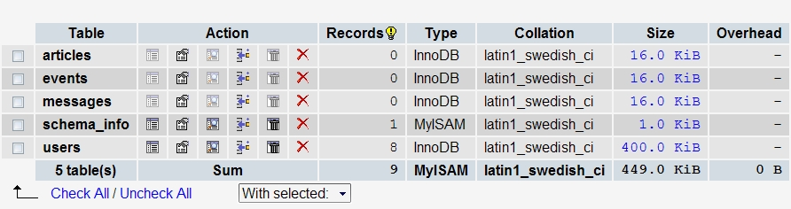
Figure 1 - Database Structure

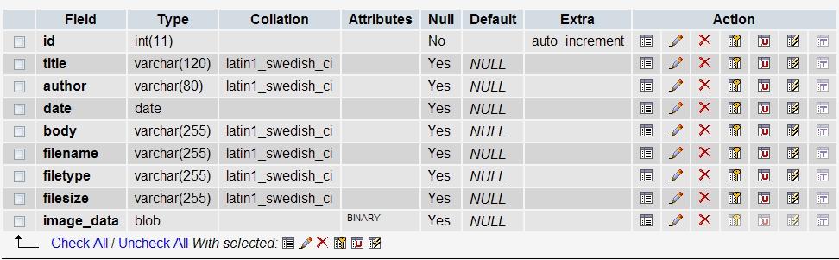
Figure 2 - Articles Table

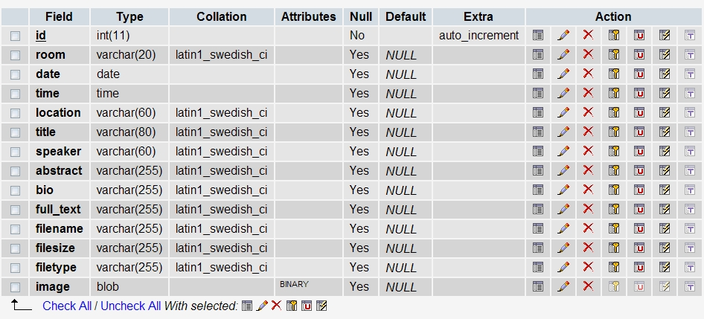
Figure 3 - Events Table

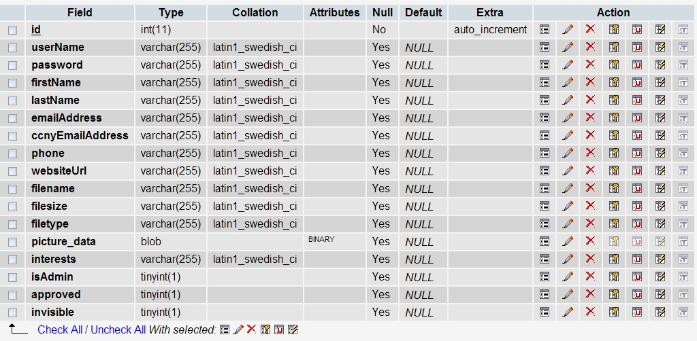
Figure 4 - Users Table

Website:
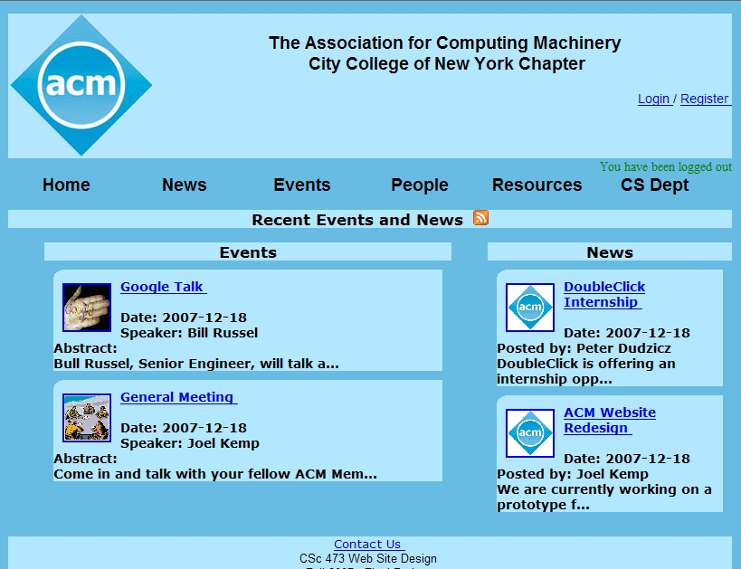
Figure 5 - Home page

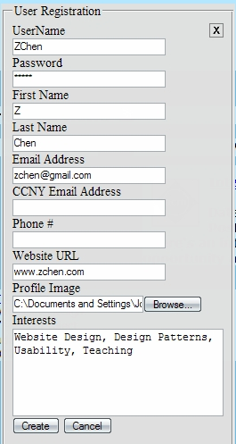
Figure 6 - Register Overlay
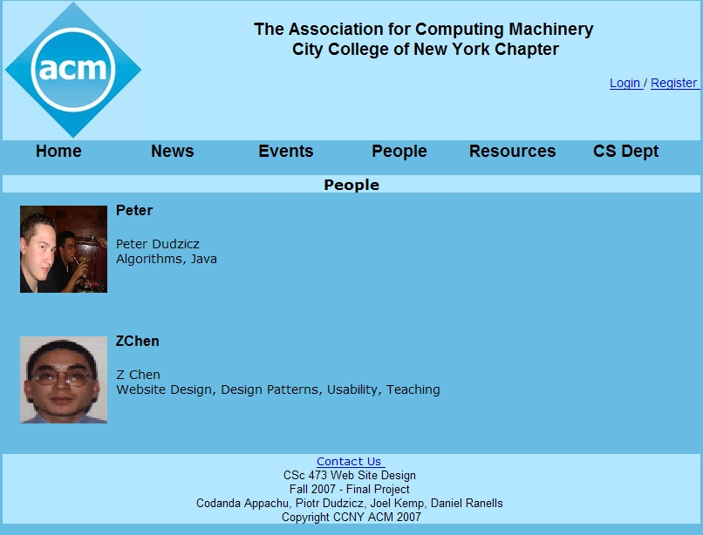
Figure 7 - People Page

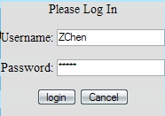
Figure 8 - Login Overlay

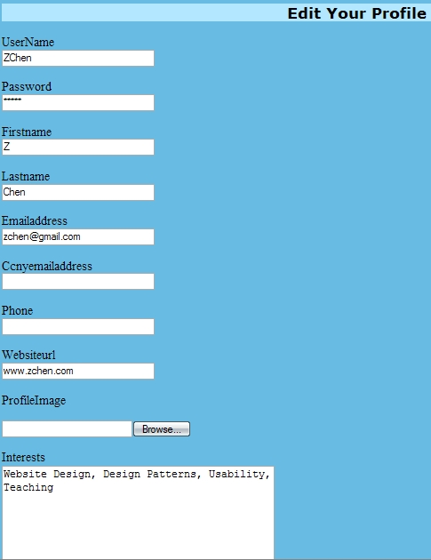
Figure 9 - Profile Edit (Top Half)

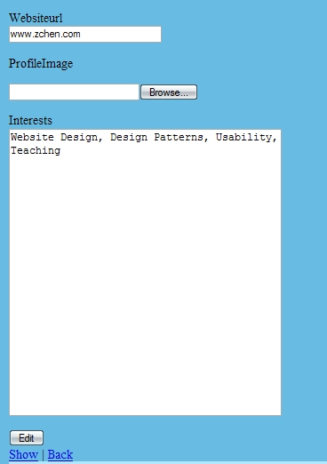
Figure 10 - Profile Edit (Bottom Half)

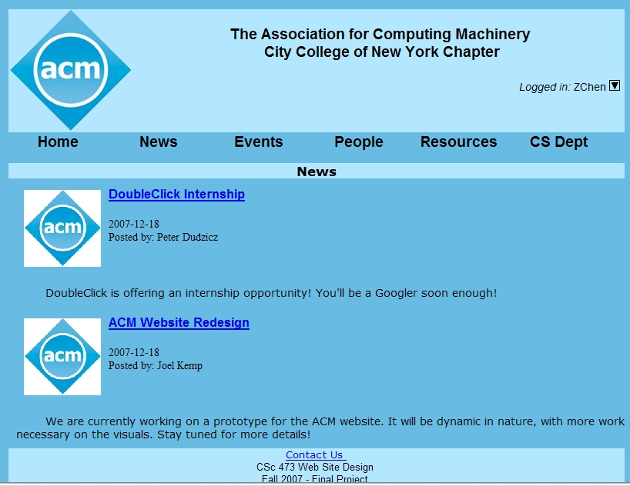
Figure 11 - News Page
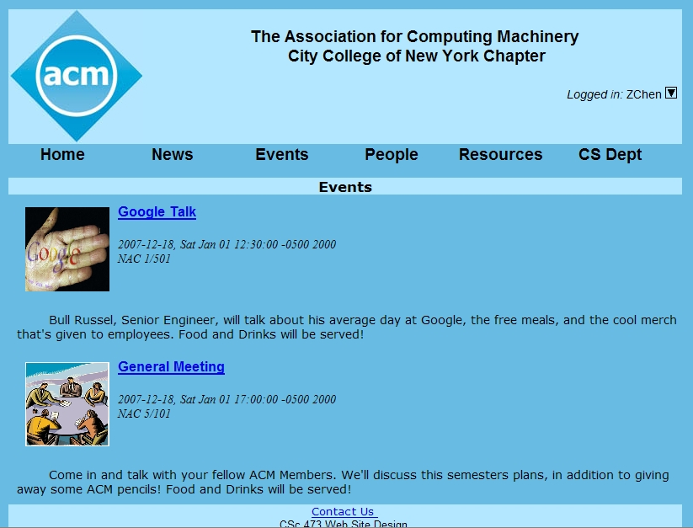
Figure 12 - Events Page

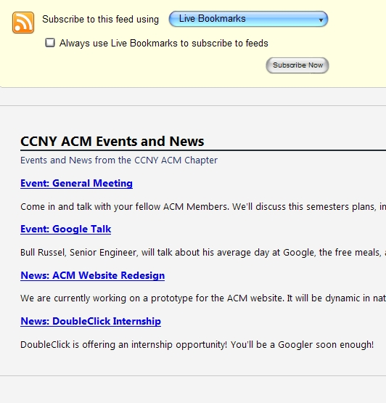
Figure 13 - RSS Feed
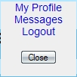
Figure 14 - User Menu Overlay
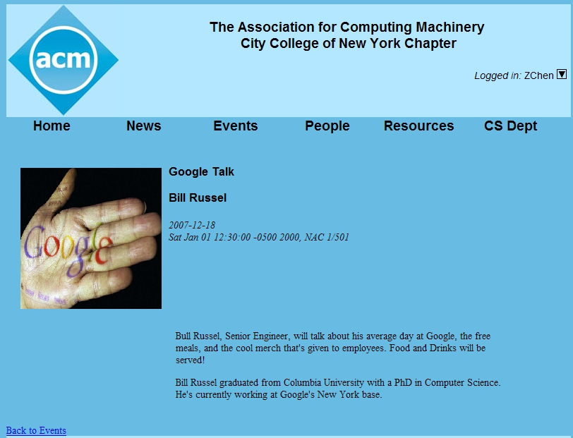
Figure 15 - Event Detail Page
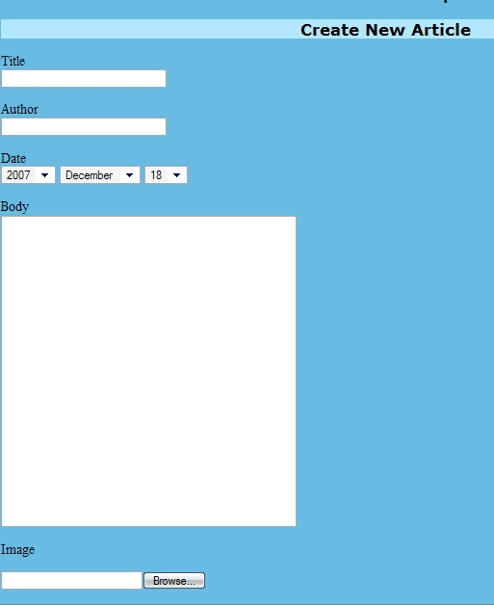
Figure 16 - Admin Create Article Page
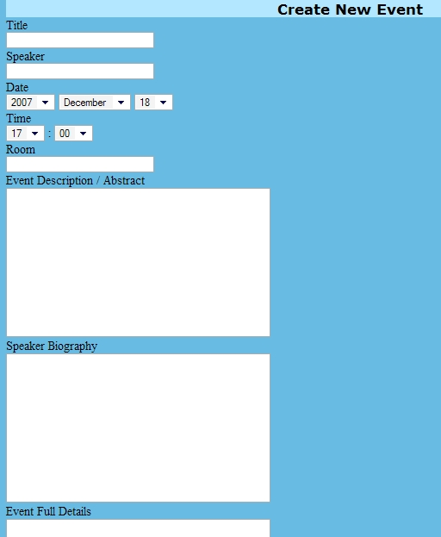
Figure 17 - Admin Create New Event (Top Half)
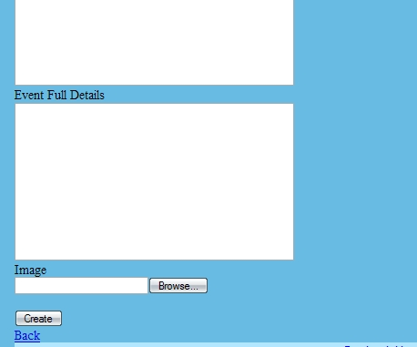
Figure 18 - Admin Create New Event (Bottom Half)

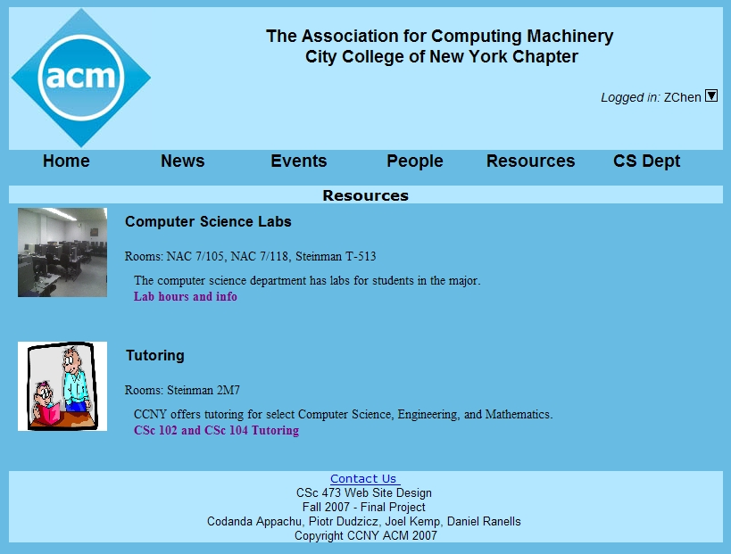
Figure 19 - Resources Page

Activating the Ruby on Rails Server & Setting up the Database
Fresh Install: No database dump provided.
- Download the latest version of InstantRails
- Install the InstantRails software
- Run the InstantRails application, which will start Apache and MySQL
- Click on the Instant Rails Logo of the main Instant Rails dialog window.
- Select Configure -> Database (via PhpMyAdmin)
- Create an empty (table-less) database called ccnyacmDev.
- Copy the source folder (ccnyacm) containing the system code submission, to C:\Ruby\InstantRails\rails_apps
- Repeat Step 4.
- Select Rails Applications -> Manage Rails Applications
- Check the box ‘ccnyacm’
- Select Start with Mongrel, to start the Ruby on Rails server.
- Repeat Step 4.
- Select Rails Applications -> Open Ruby Console Window
- Navigate to the ccnyacm folder.
- Type rake db:migrate, to populate the ccnyacmdev database with the system’s required tables.
- Open your internet browser (Firefox is preferred)
- In the address line, type in localhost:3000, to access the homepage of the new ACM Website.
Not-so-Fresh Install: Database Dump Provided.
- Download the latest version of InstantRails
- Install the InstantRails software
- Run the InstantRails application, which will start Apache and MySQL
- Click on the Instant Rails Logo of the main Instant Rails dialog window.
- Select Configure -> Database (via PhpMyAdmin)
- Import the provided SQL dump file, to create the required database and tables.
- Copy the source folder (ccnyacm) containing the system code submission, to C:\Ruby\InstantRails\rails_apps
- Repeat Step 4.
- Select Rails Applications -> Manage Rails Applications
- Check the box ‘ccnyacm’
- Select Start with Mongrel, to start the Ruby on Rails server.
- Open your internet browser (Firefox is preferred)
- In the address line, type in localhost:3000, to access the homepage of the new ACM Website.
How to Use the ACM Website
To begin using the system, make sure to import the SQL dump (ccnyacmdev) into your MySQL server. This file contains existing news articles and events.
Registering
To register, click on the Register link. This will open up an overlay that will present you with a form to fill out. Clicking “create” will activate creating a new user account. If the proper fields are supplied, you will be taken to a user listing page.
Logging In
To log into your newly created account, click the “login” link. This will open up an overlay that will ask you for your username and password. Click the “ok” button to login. Notice that you now have access to an overlay known as the “user main menu,” indicated by. In a later version of the site, the user menu will provide you with the ability to edit your profile, and view your messages. Currently, you are only able to log out.
Viewing Recent News Articles
To view the most recent news articles, you can visit the homepage, which has a feed of the most recent articles and events. Alternatively, you can also visit the “news” page. On the news page, you are presented with a list of articles, each with truncated text. By clicking on the title of the article, you are taken to a detailed view of the article’s information (location, date, and time).
Viewing Recent Events
To view the most recent news events, you can visit the homepage, which has a feed of the most recent articles and events. Alternatively, you can also visit the “events” page. On the events page, you are presented with a list of events, each with truncated text. By clicking on the title of the event, you are taken to a detailed view of the event’s speaker, abstract, biography, and full text.
Editing Your Profile
To edit your profile, you can go to the “people” page, and click on your entry. In a later version of the system, you will be able to view and edit your profile via an overlay, located in the user main menu. By clicking on your entry in the “people” page, you are taken to a larger view of your profile. Majority of the Information in the profile is hidden, for security reasons. You can edit your profile by clicking the “edit” link, located below your entry.
Logging Out
To log out of the system, click on the dropdownicon, to open the “user main menu.” Select “logout” to log out of the system.
Creating a New Article or Event
To create a new news article or event, click on “news” or “events,” respectively. If you are logged in with administrator privileges, you are presented with a link “new article” or “new event” that will take you to a form that has the necessary input fields for an article or event.
RSS Feed
To subscribe to the RSS feeds of the ACM News and Events, simply visit the homepage and click on the orange RSS icon. This will take you to a page that allows you to configure your subscription.

